Conductivity Measurements – Operating Instructions
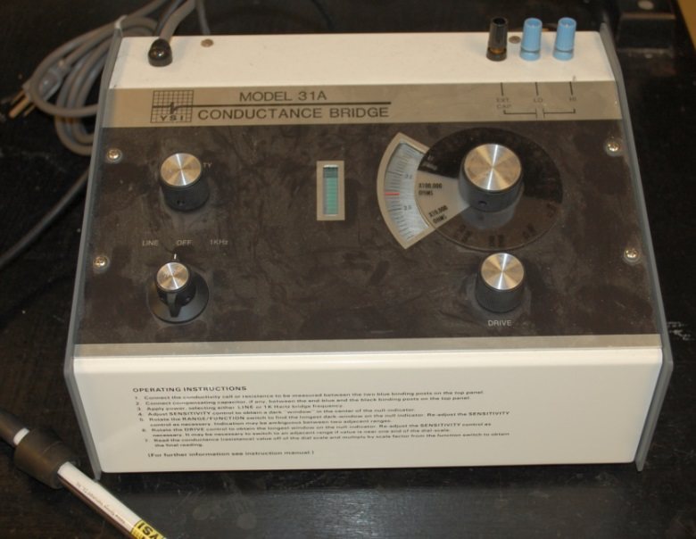
1. Connect the conductivity cell or resistance to be measured between the two blue binding posts on the top tight panel.
2. Connect compensating capacitor, if any, behind the end blue and black binding posts.
3. Apply power, select either LINE or 1K Hertz bridge frequency.
4. Adjust SENSITIVITY control to obtain a ‘dark’ window in the center pf the null-indicator.

5. Rotate the RANGE/FUNCTION switch to find the longest dark-window on the null-indicator. Re-adjust the SENSITIVITY control as necessary. Indication may be ambiguous between two adjacent ranges.
6. Rotate the DRIVE control to obtain the longest window on the null-indicator. Re-adjust the SENSITIVITY control as necessary. It may be necessary to switch to an adjacent range if value is near one end of the dial scale.
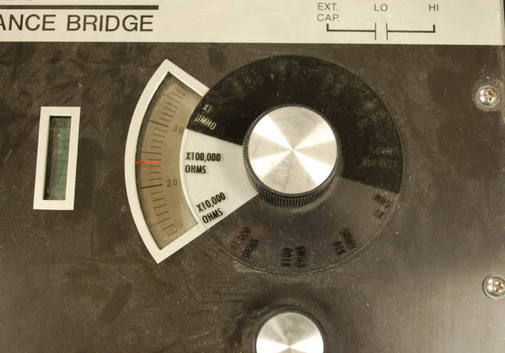
7. Read the conductance (resistance) value off the dial scale and multiple by scale factor from the FUNCTION switch to obtain the final reading.

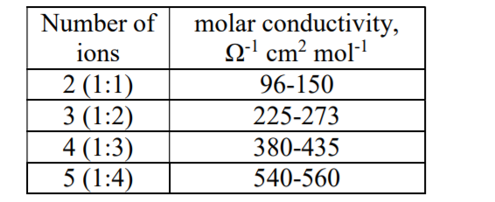
For aqueous solutions

