Using the IR Spectrometer
Procedure
Be sure that nothing is in the sample compartment.
If the ATR (attenuated total reflectance) attachment is there, gently remove it and set it on a soft surface. If you will be using NaCl plates, the black metal holder may remain or be installed later.
1. Turn on the power switch on the instrument.
2. On the computer, double click the IR Solution icon. Wait for the diagnostics to complete.
3. Init success will show on the bottom left window and three green bars on the right. If “remove marked data” appears, click OK.
4. If using NaCl plates, install the metal holder if not already installed.
5. Check the parameters on the right hand side of the screen. (for either sampling method)
Meas. mode %Transmission
Apodization Happ-Genzel
# scans 20
Resolution 4.0 (cm⁻¹)
Range (cm⁻¹)
Min 520
Max 4000

The measurement window will look like this: 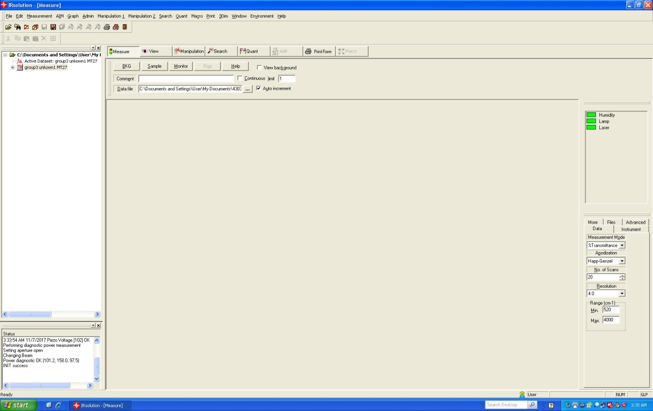

6. Take two NaCl plates from the dessicator. The plates are very fragile and must be handled carefully, and kept dry! Wet a kim-wipe with a small amount of dichloromethane (DCM) and gently wipe the plates clean.
7. Place the two plates together in the sample holder. Your instructor will demonstrate the proper procedure for this holder. Be sure that the plates sit flat in the bottom sample holder before tightening the top holder. If you do not, you will likely break the plates. Also, do not over-tighten the holder. The minimum amount of pressure required to hold the plates together is enough. Place the sample holder in the black metal holder in the instrument.
8. Record Background spectrum
Because FT-IR is a single beam method, you need to record the background spectrum, which will be automatically subtracted from sample spectra. Click the BKG button. Be sure the sample plate is clean, or the clean plates and holder are in the instrument and click OK when prompted to prepare for the background. Wait for all the scans to complete. The scan count is shown at the bottom left of the screen. The background spectrum will be displayed. This consists mainly of absorptions due to CO₂ and H₂O vapor in the air. You may need to run the background only once. If you wish, you can always perform another at a later time.
9. Record Sample Spectrum
a. On the Data File line, the path should indicate the data folder for your class. Click on the button with the three dots. Type a file name for your sample, which should include your group’s initials and sample designation. If the auto increment box is checked, a number will be added to the end of the name which will increase every time a spectrum is run.
b. Remove the NaCl plates from the holder and place ONE drop of sample in the center of a plate or gently place your Nujol mull onto the plate. Quickly put the other plate on top, and gently place the plates in the holder as before, and insert into the instrument.
c. Click the Measure tab. Click the Sample button and wait for the scans to complete. See the next page for the spectrum view window.
d. Check the strongest peaks to see that they do not go below approx. 30% transmission. If they do, you have too much sample. Usually cleaning one of the plates and returning them to the instrument and re-scanning will fix the issue. If the sample is very volatile and the peaks are too weak, try two drops instead of one.
e. On the top menu, click Manipulation 1 → Peak table. On the bottom right of the screen, click Calc to label the peaks with their wavenumbers. Click OK. (You can adjust parameters and repeat Calc to get the peaks that you want labeled.)
f. Check to see that your peak labels are all visible at the bottom of the screen. If they are not, in the bottom spectrum window, click in the lower part of the Y-axis gray area and set the Lower Y-axis value to a %T that will not cut off the labels.
You sample spectrum should looking something like this (with different peaks, of course):
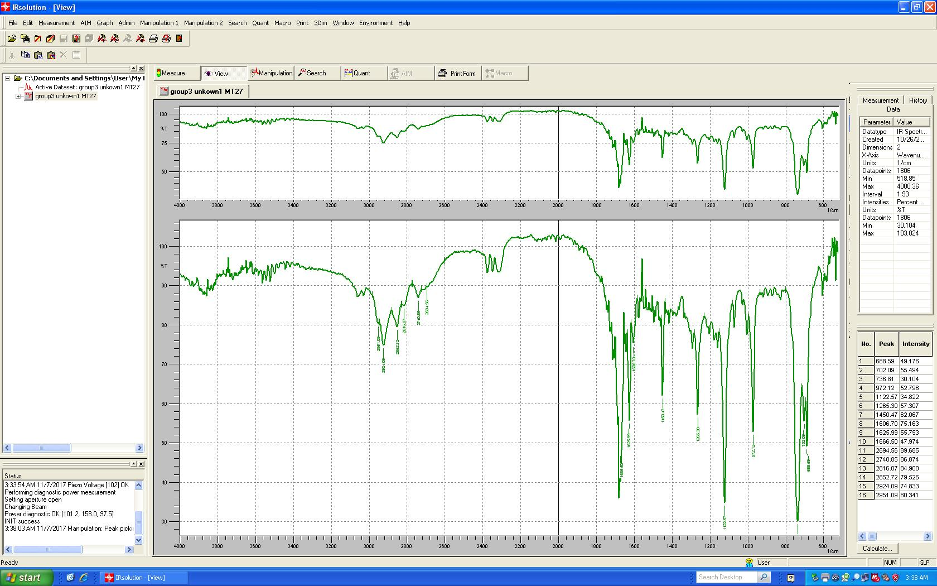

g. To change graph color for best printing and copying:
Right-click in the spectrum window (the bottom one). Click Graph Preferences. Choose the Coloring tab. Click the colored block in the Active Object Color box. Choose Black (or whatever color you want). Change Color Mapping to Overall Occurrence. Click OK.
h. To print graph:
Click File → Print with Form. Select spectrum 1.ptm. Click Open, then OK.
Clean the NaCl plates as before to prepare for the next sample, if there is one.
When you are done, store the NaCl plates. Turn off the instrument (if you are the last to use) and close the IR Solution software.

