Lab 1: Growing Crystals of Alum

This is an ongoing lab to be completed throughout the semester. Students will monitor the crystal growth and make appropriate adjustments as necessary.

SAFETY NOTE: Alum is potassium aluminum sulfate - KAl(SO₄)₂.12H₂O. It is reported to have a relatively low toxicity. However, if alum is accidently spilled on hands it should wash it off immediately with water.

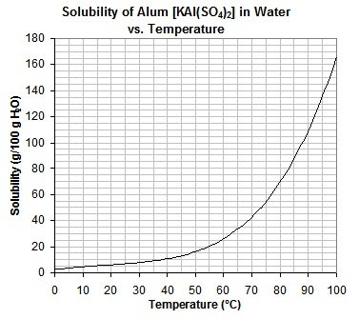
Background information
In solution, a solvent such as water can only hold a certain amount of solute such as alum. This is called the solubility of the solute. When the temperature of the solution is increased, hot water can dissolve more solute than cold water (solubility of alum in water at various temps shown in the graph).
When no more of the solute can be dissolved, the solution is said to be saturated. As this solution cools, crystallization occurs and the solid precipitates.
As the alum particles precipitate from the cooling solution, they bond with other alum particles on nucleation sites (bumps, tiny cracks, impurities, etc. in the container) and begin to form seeds for further crystallization. You’ll see this crystallization on the bottom and sides of the container and on the string hanging in the solution (used to grow the crystal).
Pure crystals usually take on a specific shape based on the elements in the compound. For instance, salt (NaCl) crystals have a cubic structure while quartz crystals are six-sided prisms. Crystals have a repeating pattern based on unique chemistry and internal molecular structure. Alum crystals have 8 sides (faces).

Growing large, good quality crystals requires patience. The crystal growing solution should be kept in a place of constant temperature and out of direct sunlight which can heat the solution. Crystals grown slowly generally have better quality than those grown more quickly. Maintaining the alum solution at a constant temperature helps the crystal grow evenly so they have a more symmetrical shape, so it helps to keep growing crystals and solutions away from areas with large temperature variations. In this lab you will just keep them at the back of the lab on top of a bench.

Note: Room temperature can fluctuate as a result of central heating and air-conditioning systems. Since we have little control over that, it is possible crystals may dissolve if the temperature increases by more than a couple of degrees (eg on weekends). If this happens, you use another seed crystal to begin again.

You will work independently on this lab and grow your own crystal throughout the semester

Materials

Alum (30 g/student)
Beaker (about 400 mL capacity)
Flask (about 500 mL capacity)
Filter paper
Spatula
Approx. 12" piece of white thread†
Popsicle stick
Thermometer

† With a cotton thread, small crystals may grow along the thread and can attach themselves to the main crystal. These actually can be very good seed crystals. But as the experiment proceeds, additional crystals that form on the thread should be removed by gently crushing them on the thread with a spatula and washing off with a stream of tap water.

Procedure

1. Record the date that the experiment begins. Keep a separate sheet for weight/date measurements of the crystal as it grows.

2. Place approx. 30 g of alum in a 400 mL beaker. Add about 350 mL of deionized water. Heat on hot-plate to no more than 70 ∘C and stir the mixture until all the solid dissolves. Heat only to a temperature that will cause the alum to dissolve.

3. Using filter paper and funnel, filter the warm solution into an empty flask, then pour the solution back to the (cleaned) 400 mL beaker. Cover the beaker with a fresh piece of filter paper to keep out dust and set aside to cool in an undisturbed place (back of lab) until next class.

4. Next lab, the bottom of the beaker should contain small crystals of alum which formed as the solution cooled. Carefully pour off the clear solution into another beaker, leaving behind the crystals. If no crystals have formed, let stand until next lab or until crystals appear.
5. Select a single nicely shaped crystal at least 5 mm long and remove it with spatula. This will be the seed crystal. Record its mass in grams. If many crystals form together as a clump, a seed crystal can be carefully broken off. Save several large crystals in case they are needed later. Tie a piece of thin thread tightly around the crystal (this can be tricky of the seed crystal is too small). Tie the other end of the thread to a Popsicle stick and suspend the crystal in the alum solution so that the crystal hangs about 2 cm from the bottom. Place the beaker in a draft-free area where it will not be disturbed.

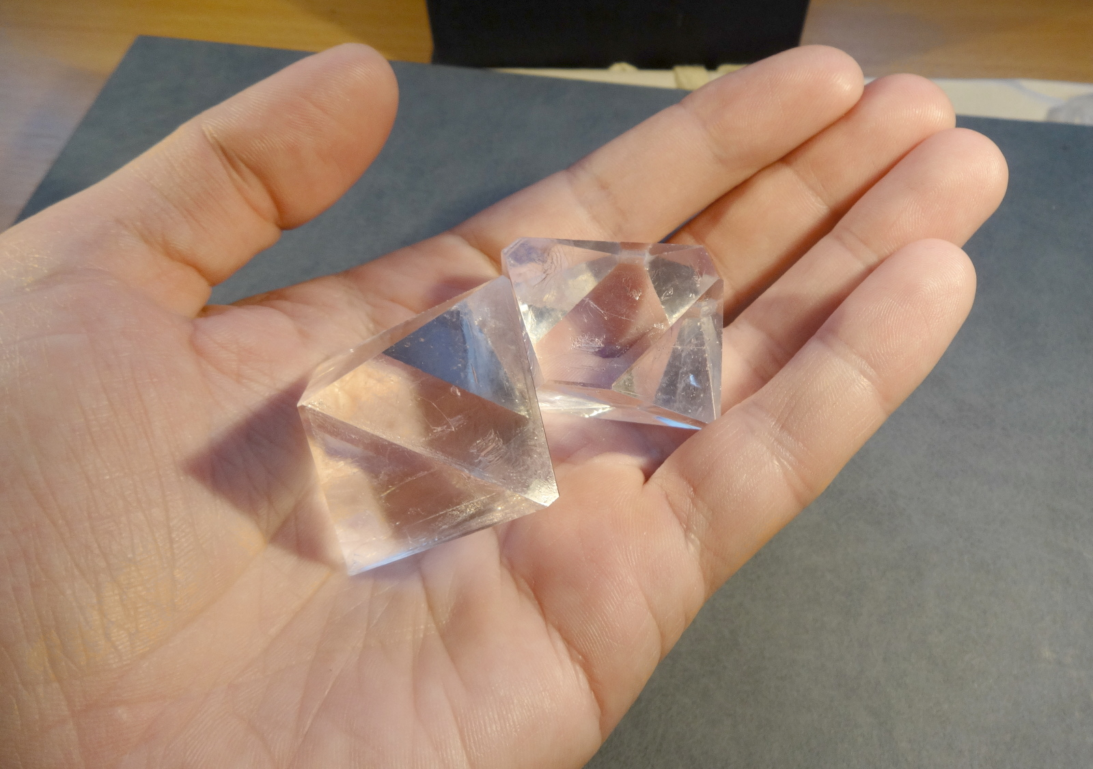
6. Over the coming weeks, the crystal should increase in size and take on the 8-sided shape of a typical alum crystal (see photo). Throughout the semester, periodically remove the crystal, dry it with a paper towel and record its mass. Record the date as well. Additional smaller crystals will probably have appeared on the bottom of the beaker. Decant the solution (or filter it) and return to a clean beaker. Re-suspend the crystal in the solution and cover as before. Keep the additional alum in a small beaker. It may be used to prepare fresh alum solution as needed.

7. Repeat step 6 every few weeks as necessary. Be sure to record the date and mass each time.

8. As the alum solution evaporates, it will be necessary to prepare more alum solution if you want the crystal to continue to grow by repeating steps 2 and 3 with more alum. Make sure the solution is cool (let sit until the next lab) before adding it to your original alum solution. The growing alum crystal should always be covered with alum solution if you want it to grow.

9. When you have finished growing the crystal towards the end of the semester, remove it from the solution and dry it with a paper towel. Cut off the thread. To help preserve the crystal, coat it with clear fingernail polish. It can then be handled occasionally with dry fingers. When dry, show to instructor for grading.

10. Save all solutions and unwanted crystals and return to instructor for recycling in container provided.

REPORT: Due at the end of the semester
BACKGROUND: What is alum? What is it used for? How is it prepared? (Refer to encyclopedias or
the Internet)

METHOD: Describe briefly the method used to grow the crystal.

PROBLEMS: Describe any problems encountered during the project and the steps taken to overcome them. Did the crystal unexpectedly dissolve? What can this be attributed to?

GROWTH DATA: Plot a graph of the crystal growth rate (cumulative mass vrs total time). Is this a straight line or a curve and would each imply? From the graph, calculate was the rate of growth from at least 3 periods during the experiment. Was it constant or did it vary?

